Parents please check choices:

Toddler ___ Primary ___
Full Day ___ 5 days/week 8:30-3:00
Ext. Morn. (5 days/wk only) __7:30-8:30
Ext. Aft. (5 days/wk only) __3:00-5:00

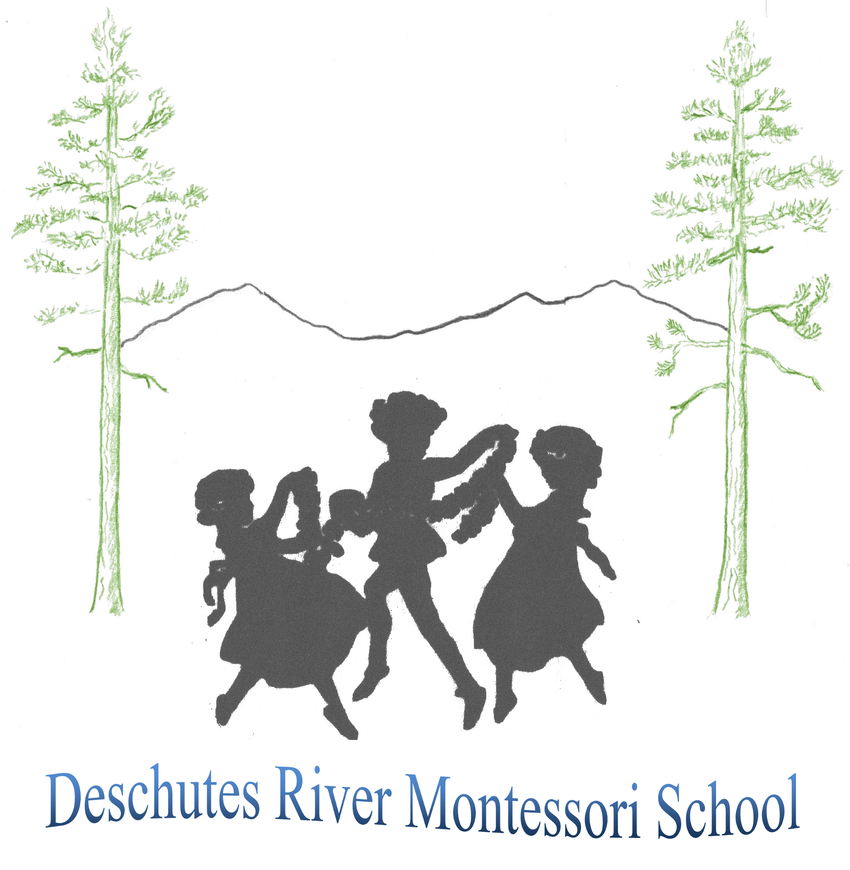
Deschutes River Montessori School
Enrollment Application for New Students
2024-2025

Child’s Full Name______________________________________Child’s Nickname_____________________________

Child’s Gender__________________ Child’s Birth date_________________ Child’s Age as of 9/1/24____________

Parent’s Name __________________ Address _______________________Zip_____ Email _____________________

Parent’s Telephone (hm) ______________________ (cell) _____________ (wk) _____________________________

Parent’s Name __________________ Address ______________________ Zip_____ Email _____________________

Parent’s Telephone (hm) ______________________ (cell) ______________________ (wk) ______________________

Names of Siblings Dates of Birth Schools Attended
________________________________ ______________________ _____________________________________

________________________________ ______________________ _____________________________________

________________________________ ______________________ _____________________________________

STUDENT’S PERSONAL HISTORY

Name of previous schools or daycare attended: ______________________ Dates attended: _______________________

List three words to describe your child:

(Parent) ________________________________________ (Parent) __________________________________________

Do you now or have you ever had concerns about your child’s development and behavior?

If yes, please describe: ______________________________________________________________________________
_____________________________________________________________________

Has anyone recommended that your child be evaluated or screened for psychological, behavioral, or developmental difficulties? _______________________________________________________________________________________

Are there any special needs you anticipate your child having, such as diet, allergies, vision, hearing, special academic, social/behavioral, or physical?________________________________________________________________________
_________________________________________________________________________________________________

Does your child have any specific fears or anxieties of which we should be aware? ______________________________
_____________________________________________________________________

Describe the type of discipline used in your home ________________________________________________________
_________________________________________________________________________________________________

Describe your child’s level of toilet training. _____________________________________________________________
_________________________________________________________________________________________________
Is there anything else about this child that we should know in order to understand him/her more fully? _________________________________________________________________________________________________
PARENT INVOLVEMENT

As parents of a child enrolled at Deschutes River Montessori School, you are invited to invest your time and share you knowledge, interests, and skills. Please fill in your name and occupation and indicate with which of the projects you would be willing to participate.

Parent______________ Occupation_________________ Parent______________ Occupation_________________

_________Classroom Materials Creation _________Classroom Materials Creation
_________Classroom Speaker/Presenter (skill, career) _________Classroom Speaker/Presenter (skill, career)
_________Hospitality/Special Events _________Hospitality/Special Events
_________Small Construction Projects & Repairs _________ Small Construction Projects & Repairs
_________Periodic Deep Cleaning _________Periodic Deep Cleaning
_________Sewing Projects & Repairs _________Sewing Projects & Repairs

GENERAL INFORMATION & PERMISSION
How did you learn of Deschutes River Montessori School? _________________________________________________
Why would you like your child to attend Deschutes River Montessori School? __________________________________
_____________________________________________________________________

Montessori Education is a preparation for life, supporting children as they develop life skills such as independence, initiative, concentration, a love of learning, and a positive self confidence. Our program is designed to meet children’s developmental needs through and including their kindergarten year: emotionally, socially, academically, and physically. We give priority registration to children who will be enrolled with DRMS through this very important kindergarten year.

Please describe your plans for your child’s kindergarten year (the kindergarten year is considered integral to your child’s Montessori preschool experience): _____________________________________________________________

Please describe your plans for your child’s ongoing education through the elementary years:______________________
_____________________________________________________________________________________________

Occasionally, photographs of the children working and playing in the classroom and out-of-doors will be taken. I/We give our permission (required) for photos of our child to be displayed at school, published in school promotional materials such as brochures or advertisements, or used in media coverage. No names will be printed.

Parent Signature & Date___________________________ Parent Signature & Date_____________________________

We give our permission (required) for our child to go on walking “field trips” to nearby neighborhood parks. We understand that a minimum of two DRMS teachers or assistants will supervise all trips.

Parent Signature & Date___________________________ Parent Signature & Date_____________________________

A one-time, non-refundable application fee of $20 must be submitted with this application – mail to DRMS, 929 SW Simpson Ave, STE 130, Bend, OR, 97702. This fee is required for your application to be complete and to be added to our wait list. All prospective students and their parents must meet/ tour with the Executive Director or Director of Operations prior to acceptance into the program. Applying for enrollment does not guarantee placement in our programs.

Upon acceptance, a non-refundable Annual Enrollment Fee of $400 and a signed Enrollment Agreement are required to reserve and hold a place for your child. The Enrollment Agreement is considered a binding contract for the school year; exceptions made at the discretion of the Director(s). An Annual Supply Fee of $300 is also due with the Enrollment Agreement. I understand the above two fees are in addition to my child’s annual tuition and must be submitted before the start of school. ___initial

Deschutes River Montessori School has a non-discriminatory policy relative to race, color, and national origin with respect to the admission of students and the employment of faculty and staff.

